**Task-3**

**CRUD Calls From BPM**

**Task Overview:**

The fields which were displayed in Task-1 left side of the screen will be displayed by making the database call from BPM. We will create a general system service to do a data base call and we will bind those details to the Human service.

**Solution:**

Before going to do database call we have to configure the JDBC in WAS( WebSphere Application Server) Level. Create a General system service, drop a "Nested service Component" and add "SQL Execute Statement" integration service in Implementation Properties. Write TwScript Logic to retrieve the details from database. Our BPD instance will be created with the input where we can find customer unique number(Refer Task-1 for how our BPM is triggered). We will pass the Customer Unique number to fetch the records and store those details in a Business Object we will pass those details to Human Service for the Maker team to check or modify the details. We have to store the details in database whenever the Maker team submit the screen to Verification team.

**Requirements:**

1.IBM BPM v 8.x.

2. Database details (i.e., username, password, db name, port number).

3. Data Source Name.

4.Table Name, Column Details.

**Implementation:**

* Configure the DataSourceName in environmental variables.
* Create a General System Service to get customer details from Database, In GSS drag a Server Scriptlet and write an sql query to get the details

**"select * from CUSTOMERDETAILS where UNIQUEID=<#= tw.local.EmpId #>"**

the above query is for getting dynamic results

* Drag and drop a nested service and select sql execute statement (Sql Result)
* You should set Data Mapping values those are input variable and DataSourceName

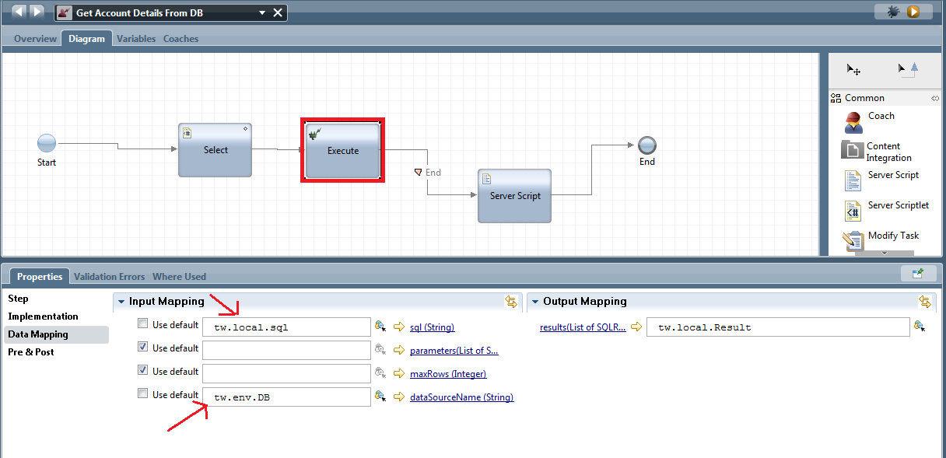

* Drag the Server Script and assign the output values to the Business Objects as follows

**tw.local.PersonalInfoBO=new tw.object.PersonalInfoBO();**

**tw.local.WorkDetails=new tw.object.WorkDetails();**

**tw.local.ContactInfo=new tw.object.ContactInformation();**

**//PERSONALDETAILS**

**tw.local.PersonalInfoBO.CustomerName=tw.local.Result[0].rows[0].indexedMap["CUSTOMERNAME"];**

**//tw.local.PersonalInfoBO.TypeOfAccount=tw.local.Result[0].rows[0].indexedMap["TYPEOFACCOUNT"];**

**tw.local.PersonalInfoBO.PassPortNumber=tw.local.Result[0].rows[0].indexedMap["PASSPORTNUMBER"];**

**tw.local.PersonalInfoBO.AadharNumber=tw.local.Result[0].rows[0].indexedMap["AADHARNUMBER"];**

**tw.local.PersonalInfoBO.Dob=tw.local.Result[0].rows[0].indexedMap["DATEOFBIRTH"];**

**tw.local.PersonalInfoBO.Email=tw.local.Result[0].rows[0].indexedMap["EMAILID"];**

**tw.local.PersonalInfoBO.PanCardNumber=tw.local.Result[0].rows[0].indexedMap["PANCARDNUMBER"];**

**//WORKDETAILS**

**tw.local.WorkDetails.EmployeeType=tw.local.Result[0].rows[0].indexedMap["EMPLOYEETYPE"];**

**tw.local.WorkDetails.CompanyName=tw.local.Result[0].rows[0].indexedMap["COMPANYNAME"];**

**tw.local.WorkDetails.OfficeAddr=tw.local.Result[0].rows[0].indexedMap["OFFICEADDRESS"];**

**tw.local.WorkDetails.DateOfJoin=tw.local.Result[0].rows[0].indexedMap["DATEOFJOINING"];**

**tw.local.WorkDetails.MonthlyIncome=tw.local.Result[0].rows[0].indexedMap["MONTHLYINCOME"];**

**tw.local.WorkDetails.Role=tw.local.Result[0].rows[0].indexedMap["ROLE"];**

**//CONTACTINFO**

**tw.local.ContactInfo.ContactNumber=tw.local.Result[0].rows[0].indexedMap["CONATCTNUMBER"];**

**tw.local.ContactInfo.PresentAddr=tw.local.Result[0].rows[0].indexedMap["PRESENTADDRESS"];**

**tw.local.ContactInfo.PermanentAddr=tw.local.Result[0].rows[0].indexedMap["PERMANENTADDRESS"];**

**tw.local.ContactInfo.Pincode=tw.local.Result[0].rows[0].indexedMap["POBOXNO"];**